Wiggle Wiggle

Clap Clap

Nod Nod

Clomp Clomp

Shake Shake

Boo Boo

 

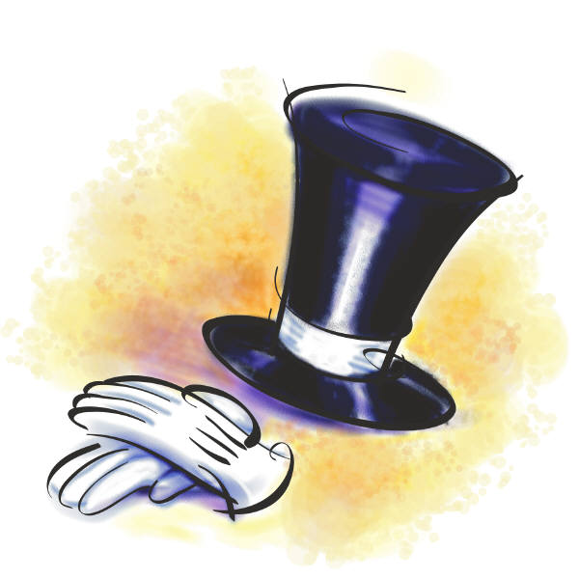 

 

**Directions**: *Circle the word that goes with the right picture and connect them with a line. After that, label the pictures in order in which they appeared in the story. For example, put a number 1 next to the picture that comes first in the story and so on.*

**Name:**

**Date:**

***The Little Old Lady Who Was Not Afraid of Anything***