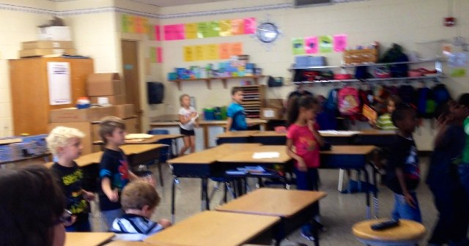

Mrs. Anderson’s Class

# First Grade

Class Profile

Cooperating Teacher:

Mrs. Anderson

Others Who Assist:

Some of the moms in the class will come in and help out Mrs. Anderson occasionally.

Grade Level and Subjects taught:

First grade; Because Mrs. Anderson is an elementary teacher, she has to teach all of the core subjects, such as math, language arts, science, and social studies.

Gifted Students:

Not in my class, but definitely in the grade.

Inside Jokes:

They have many inside jokes which keep the students on track and have fun while doing their work.

Daily Routines:

The students come in, do their work, and go to lunch. After lunch, they either go to recess (if it’s Tuesday), or continue their centers. After that, they either have P.E., Music, or Art.

Behavior/Discipline Plan:

In our class, you can either earn a Mighty Groan (if you’re bad), or an OH YEAH! (if you’re good).